**Crowdfunding Curriculum Template Summer 2015**

**Lesson 1: Introduction to Food Security**

**Instructional Activities**: a) Proportional reasoning/scaling/counting, b) Viewing video, & c) Application of Statistics - Extrapolation

**Prerequisites**: middle school mathematics

**Instructions**:

Due to the variable nature of class size and setting, these instructions will be given as percentages. All data/statistics are coming from the UN’s World Food Program using their most recent data from the Food and Agricultural Organization (FAO) of the UN. The challenge here is to take global statistics and translate it to the number of students. It would be beneficial to read the Further Background before running this.

Here are the hunger/chronically undernourished statistics that can be used:

A. Globally - 795 million hungry people of a population of 7300 million = 11 %

B. USA proportion of undernourished <5%

C. North Korea (Democratic People’s Republic of Korea) proportion of undernourished = 42%

D. South Korea (Republic of Korea) proportion of undernourished <5%

E. Dominican Republic proportion of undernourished = 12%

F. Haiti proportion of undernourished = 53%

1. Display a world map

2. How many kids are in your class today? Before introducing the lesson, pass out equal # of index cards with the numbers 1-10. Extra student(s) can be employed as counters

3. Ask students if they have ever heard the terms **Food Security & Undernourished,** and ask what they believe the terms means. There is no right or wrong answer at this point.

4. Give the students the Global Hunger percentage and have them determine which combination of cards distributed equals 11%. CC – math standard [CCSS.MATHCONTENT.7.RP.A.2.A](http://www.corestandards.org/Math/Content/7/RP/A/3/)

5. Ask students to predict what the % undernourished is in the USA or Canada?

6. Give them a value (4% is a high end estimate) and have them determine which combination of cards distributed that equals 4%.

7. Next it is your choice. A suggestion: two sets of countries that share common borders are given. Compare Haiti to Dominican Republic, or North vs. South Korea, or you can use any combination of countries of your choosing off of the [FAO’s World Hunger Map](http://www.fao.org/hunger/en/)

8. Repeat having kids determine which combination of cards distributed equals the % undernourished.

9. Display the high resolution [UN World Hunger Map](http://www.wfp.org/content/hunger-map-2015) and ask if students see any patterns.

10. At this point, many issues/ideas should begin to surface, e.g. political system, geographic local, state of the country’s economy, infrastructure, etc. Let the conversation brew while you set up the Frontline video.

11. Pass out the video guide for Food for Thought and have students preview the questions.

12. Show [Food for Thought](http://www.tffchallenge.com/documentary) – a documentary on the young innovators tackling the challenge to feed 9 billion humans.

13. Lead a class discussion to come up with a class definition, and then compare that to the definition given by the World Health Organization. See below: Lead the class into the idea that food security is not just an American issue, but world-wide, and is not just about growing more food or eliminating poverty.

Source of Statistics – [UN’s World Food Program](http://www.wfp.org/)

***World Health Organization Definition of Food Security***

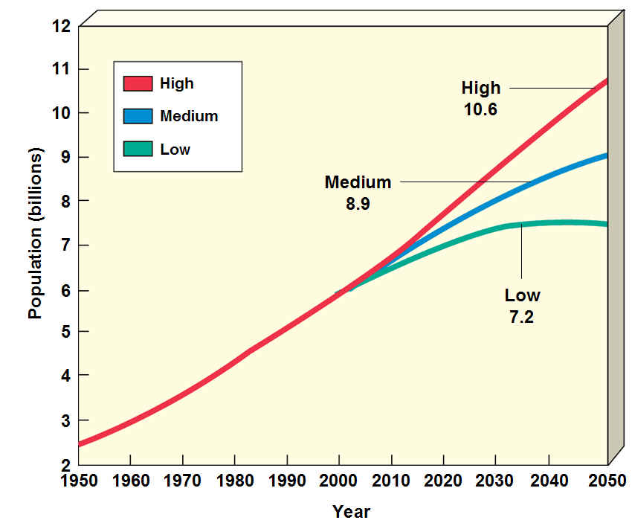*The World Food Summit of 1996 defined food security as existing “when all people at all times have access to sufficient, safe, nutritious food to maintain a healthy and active life”. Commonly, the concept of food security is defined as including both physical and economic access to food that meets people's dietary needs as well as their food preferences. In many countries, health problems related to dietary excess are an ever increasing threat, In fact, malnutrion and foodborne diarrhea are become double burden.*

[*http://www.who.int/trade/glossary/story028/en/*](http://www.who.int/trade/glossary/story028/en/)

14. Wrap Up Activity and prep for formative assessment:

a**.** Show the following projections:

Figure 1 – from Department of Geography – [Hunter College, City University of New York](http://www.geography.hunter.cuny.edu/~tbw/ncc/Notes/Chapter6.pop/chapter.6.factors%20affecting.human.pop.size.outline.html) – UN Projections based on three Total Fertility Rates (TFR) of 2.6 (high), 2.1 (medium), or 1.7 (low)

b. Remind students that currently 11 % of the global population is undernourished.

c. Using Figure 1 above, have students determine the percent growth, from today predicted by the medium TFR, of Earth’s population in 2050.

Example Calculation

Projection numbers:

Current global population: 7300 million

Projected global population in 2050: 9500 million

What is the percent increase in population?

(9500 – 7300)/7300* 100 = 30.% increase

d. Using this % increase and current hunger trends, how many hungry humans will there be in 2050?

Example Calculation

Projection numbers:

Current global population: 7300 million

Projected global population in 2050: 9500 million

Number of hungry people: (95/73)*795 = 1030 million (approximately 3x USA population)

e. Is this an exaggerated or conservative value? Explain

15. Assessment: formative – Single question free response - The population of the planet is growing very quickly. Is the answer to the problem of increasing global food insecurity as the population expands simply growing more food? Justify your answer.

**Resources:**

a) Poster paper, paper or white board, numbered index cards,

b) Map of the World

c) Food For Thought video & video guide,

d) World Hunger Map,

e) Further background information for teacher:

Food security is built on three pillars:

* Food availability: sufficient quantities of food available on a consistent basis.
* Food access: having sufficient resources to obtain appropriate foods for a nutritious diet.
* Food use: appropriate use based on knowledge of basic nutrition and care, as well as adequate water and sanitation.

Food security is a complex sustainable development issue, linked to health through malnutrition, but also to sustainable economic development, environment, and trade. There is a great deal of debate around food security with some arguing that:

* There is enough food in the world to feed everyone adequately; the problem is distribution.
* Future food needs can - or cannot - be met by current levels of production.
* National food security is paramount - or no longer necessary because of global trade.
* Economic Globalization may - or may not - lead to the persistence of food insecurity and poverty in rural communities.
* Increasing food production to meet future growing population demands may or may not lead to increased negative environmental impacts.
* Climate change may or may not make agricultural production more difficult

Issues such as whether households get enough food, how it is distributed within the household and whether that food fulfils the nutrition needs of all members of the household show that food security is clearly linked to health.

Agriculture remains the largest employment sector in most developing countries and international agriculture agreements are crucial to a country's food security. Some critics argue that trade liberalization may reduce a country's food security by reducing agricultural employment levels. Concern about this has led a group of World Trade Organization (WTO) member states to recommend that current negotiations on agricultural agreements allow developing countries to re-evaluate and raise tariffs on key products to protect national food security and employment. They argue that WTO agreements, by pushing for the liberalization of crucial markets, are threatening the food security of whole communities. Related issues include:

* What is the net impact of the further liberalization of food and agricultural trade, considering the widely differing situations in developing countries?
* To what extent can domestic economic and social policies - and food, agricultural and rural development policies - offset the diverse (and possibly negative) impacts of international policies, such as those relating to international trade?
* How can the overall economic gains from trade benefit those who are most likely to be suffering from food insecurity?
* Do gains “trickle down” to enhance economic access to food for the poor?
* How can food and agricultural production and trade be restrained from the over-exploitation of natural resources that may jeopardize domestic food security in the long term?
* How to ensure that imported food products are of acceptable quality and safe to eat?

f) Additional resources for teacher:

[8 Documentaries (related to food security) that will keep students engaged](https://www.wfp.org/blog/blog/teachers-8-documentaries-will-keep-students-engaged-over-summer)

[A Place at the Table Educator Guide](https://tribecafilminstitute.org/images/uploads/film_files/Place_Table_EG_RD17.pdf)

[A Place at the Table Instant Video or DVD](https://tribecafilminstitute.org/education/film/a_place_at_the_table)

[TED talks – Josette Sheeran – Head of the UN World Food Program – Ending Hunger Now](https://www.ted.com/talks/josette_sheeran_ending_hunger_now)

[TED talks – Ellen Gustafson – Obesity + hunger = 1 global food issue](https://www.ted.com/talks/ellen_gustafson_obesity_hunger_1_global_food_issue)

[**www.wri.org/publication/great-balancing-act**-used](http://www.wri.org/publication/great-balancing-act-used) in lesson 4

[**www.sciencemag.org/content/309/5734/570/F2.expansion.html**](http://www.sciencemag.org/content/309/5734/570/F2.expansion.html)

[**http://www.fao.org**](http://www.fao.org/docrep/018/i3434e/i3434e/pdf) **loaded with lots of great information**

[**http://www.un.org/en/sustainablefuture/food.asp**](http://www.un.org/en/sustainablefuture/food.asp)

www.unglobalcompact.org search for Scaling Up Food and Agriculture

**http://www.fewresources.org** click on the energy tab and you will see the article: farms_feedlots_forests_climate_change_issues.html

Some further issues to think about:

* 1. There are hungry people now, both in the US and worldwide.
  2. The global population is growing rapidly. Current population is estimated at 7 billion people now and to expand to 9 billion by 2050. Do Homo sapiens have a carrying capacity like other organisms do?
  3. Can this problem be solved by simply growing more food? Just as in any system, there are limiting factors and tipping points. There are some huge issues dealing with natural resources and agricultural degradation of the environment to consider, as well as climate change in general.
  4. What input do stakeholders have? Is that input equally considered in policy making?
  5. How robust and resilient is our food supply now?

**Accommodations: none**

**Extension Activities: none**